California Off-Road Vehicle Association
1500 El Camino #352 Sacramento, CA 95833
info@corva.org

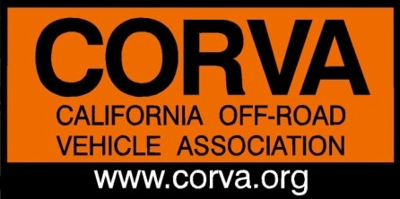
California Off-Road Vehicle Association Annual Board of Directors Meeting

AGENDA PART 1
April 27, 2020 7:00pm to 9:00pm
Call in Phone Number: (712) 775-8968• Access Code: #104206

- 700 PM Call to Order

- 7:05 PM Welcome from President
      - Introduction/ Board of Directors and Guests
      - Review/Revise Agenda

- 7:15 PM Approve minutes from 2019 Annual Meeting

- 7:20 PM Covid-19 Update: Bruce Whitcher

- 7:30 PM Legislative/Lobbyist Review

      - Carnegie SVRA: Diana M/Bruce B

- 7:45 PM OHMVR Commission review: Special Guest, Sarah Miggins, Chair OHMVR Commission

- 8:00 PM Oceano Dunes Update: Special Guest, Jim Suty, President Friends of Oceano Dunes

- 8:15 PM State Parks: Special Guest, Brian Robertson, Chief OHMVR Division

- 8:30 PM CORVA OHV Leadership

- 8:45 PM Update on Family Fun Run

AGENDA PART 2
May 18th, 7pm
Call in Phone Number: (712) 775-8968• Access Code: #104206

- 7:00 PM Call to Order

      - Roll Call & Welcome from President
      - Introduction of Board of Directors and Guests
      - Review /Revise Agenda

- 7:15 PM Review Bylaw Change Proposals, Discussion and Voting

- 7:30 PM Officer Nominations and Elections: Ken Clarke and Amy Granat
      - VP Administration:
      - VP Education: Jared MacLeod
      - Treasurer: Mike Moore

- 7:45/8:00 PM 2019 CORVA Awards
      - Nominations
      - Discussion
      - Voting by Board of Directors

- 9:00 PM Adjourn CORVA 2020 Annual Meeting

