AGENDA
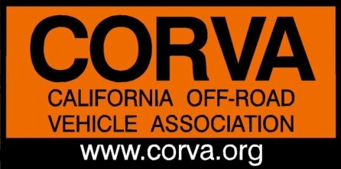
California Off-Road Vehicle Association
Board of Directors Meeting Conference, Feb. 24, 2020, 7:00 PM
Phone Number: (712) 775-8968• Access Code: #104206

- Call to Order - 7:00 PM

- Roll Call & Welcome Guests: Board members: Amy Granat, Ken Clarke,

- Review Agenda: modify as necessary
Part 1: Advocacy

- Critical & Legislative Issues; Events, Reports from the Field

  - Presidents report
  - Managing Directors report
  - Oceano Dunes, Update, ‘Stand for the Sand” rally report
  - New legislation
  - Ed’s OHV Celebration with Friends of Jawbone
  - Additional field reports, North and South
  - Feb. 27, OHMVR Commission meeting
  - Guest comments and questions
  - CORVA annual meeting
  - CORVA 50th Anniversary

Part 2: CORVA Business Items

- CORVA Tresurer’s report: Mike Moore (financial reports to be sent by e-mail)

- CORVA: Approve Meeting Minutes -

- TBD

- Adjourn, no later than 9:00 pm

Next CORVA BOD Conference Call: Mar. 23, 2020, 7:00pm

Protecting public land for the people, not from the people, since 1970
California's Off Road Voice for Access

