California Off-Road Vehicle Association
1500 El Camino #352 Sacramento, CA 95833
info@corva.org

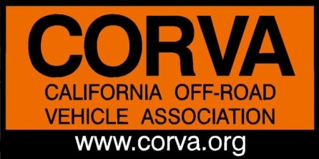
California Off-Road Vehicle Association Annual Board of Directors Meeting Minutes

AGENDA PART 2
May 30, 2019 7:00 PM

Call in Phone Number: (712) 775-8968• Access Code: #104206

- 7:00 PM Call to Order, reconvened at 7:13pm

      - Roll Call & Welcome from President
      - Board of Directors: Ken Clarke, Mike Moore, Vinnie Barbarino, Charlie Lowe, Bruce Brazil, Diana Mead, Lori Lewis, Amy Granat, Ed Stovin, Bruce Whitcher, Jim Woods
      - Guests: Jared McCloud, Terry Work, Steven Howard, Ian & Brittany Lane – Lohse, Ed Waldheim, John Roberts
      - Review /Revise Agenda

- 7:15 PM Review Bylaw Change Proposals, Discussion and Voting
Bylaw change #1 – change term of Past President to time until a new President is elected - Accepted Unanimously
Bylaw change #2 – eliminate the position of VP of Sales and Marketing
In Favor: x,x,x,x,x
Against: x,x,x,x,x,x,x,x
Abstain: x,x
Bylaw change #3 – remove Newsletter from notification method for all meetings -
In Favor: x,x,x,x,x,x,x,x,x
Against: x
Bylaw change #4- revisit next year
Against – Unanimous vote, did not pass

- 7:45/8:00 PM 2018 CORVA Awards
      - Nominations:
        - Los Aventureros: Imperial County De Anza Rescue Unit
        - Northern Club of the Year: Frank Raines RC Crawlers
        - Southern Club of the Year: Pt. Mugu 4WD Club
        - Off Roader of the Year: Jim and Roberta Woods
        - Looney Duners Charity Award: Orange County Dualies
        - ABA Ed Waldheim Political Action Award: Butch Meyner

      - Past President’s Award – Roberta Woods

- Motion made to appoint Charlie Lowe to VP of Sales and Marketing, motion made by Ken Clarke, seconded by Amy Granat: approved unanimously

- 8:55 PM Adjourned CORVA 2019 Annual Meeting, motion made by Bruce W, seconded by Bruce B, motion passed

