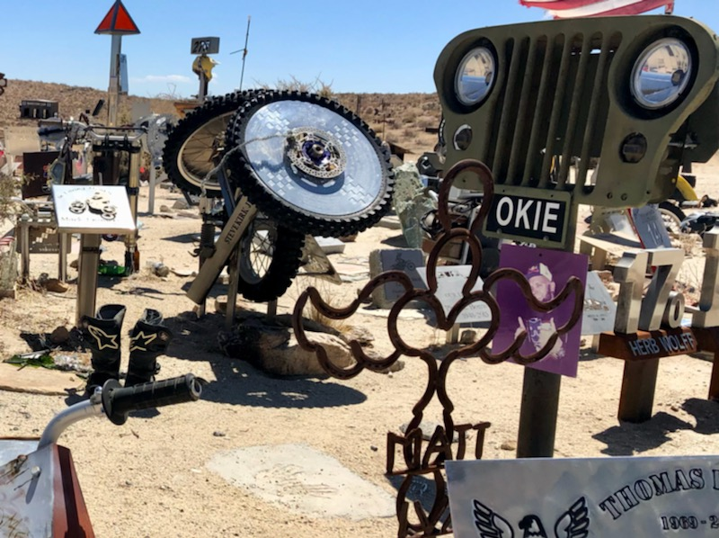

Off-Road Memorials
  - California
Photos by Scott Stacy

Proposal by Scott Stacy, requesting CORVA help with improvements for the following OHV memorials: Husky Memorial Musgee Canyon, Wagon Wheel, Ridgecrest.
- Secure Metal Trash Can with Lid

- Metal Secure BBQ, like those found in established campgrounds

- Metal Guest Book

- Bench for visitors to sit and reflect
Husky Memorial
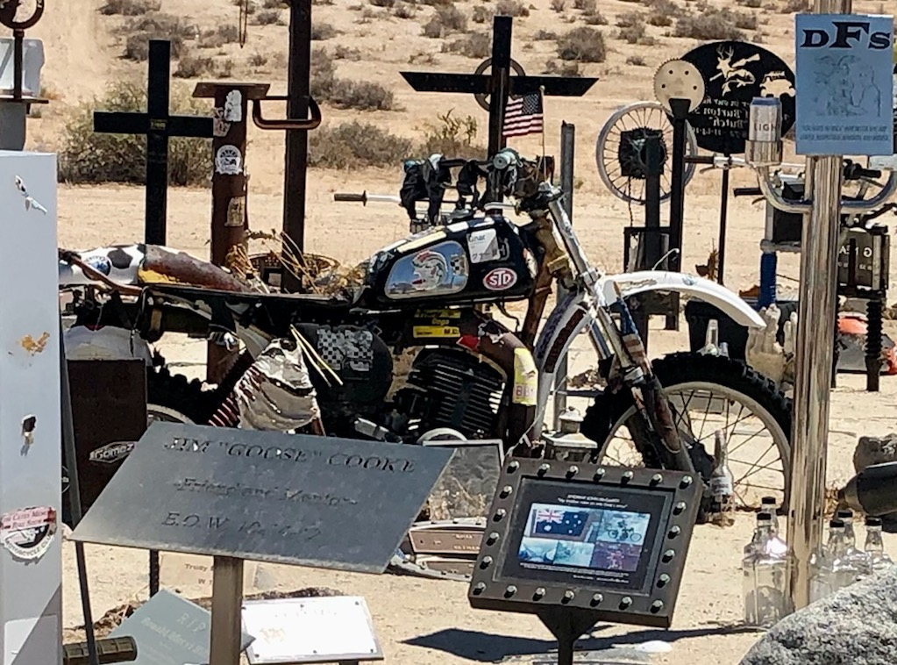 | Musgee Canyon

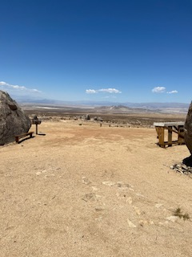 | Wagon Wheel  Ridgecrest
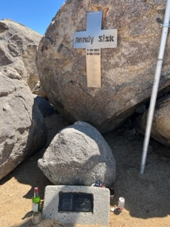

With CORVA’s involvement and support, more off-roaders will find out and support these AWESOME Off-Road Memorials

