California Off-Road Vehicle Association
1500 El Camino #352 Sacramento, CA 95833
info@corva.org

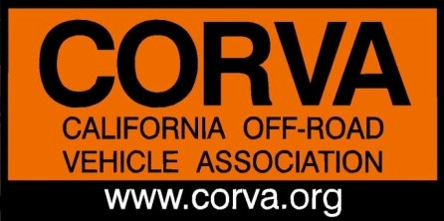
California Off-Road Vehicle Association Annual Board of Directors Meeting

AGENDA PART 1
April 27, 2019 9:00 AM – 5:00 PM
Best Western, 10386 California City Blvd, California City
Call in Phone Number: (712) 775-8968• Access Code: #104206

- 9:00 AM Call to Order

- 9:05 AM Welcome from President
      - Introduction/ Board of Directors and Guests
      - Review/Revise Agenda

- 9:15 AM Approve minutes from 2018 Annual Meeting

- 9:20 AM Legislative/Lobbyist Review: Ed Stovin & Bob Ham
      - SB 767
- 10:00 AM SB 402 Inyo County Presentation: Mike Johnston/Eastern Sierra 4WD Club

- 11:00 AM Red Rock Canyon State Park General Plan Revision: Karen Sanders/Ridgecrest Roundtable

Lunch Continuation of Red Rock Review and Conversation (if needed)

- 1:00 PM Oceano Dunes Legal and Planning Review: Bruce Whitcher

- 2:00 PM CORVA OHV Leadership

- 3:00 PM Officer Nominations and Elections: Ken Clarke and Amy Granat
      - President
      - VP Land Use & Public Policy
      - VP Sales & Marketing
      - Secretary

AGENDA PART 2
May 30th, 7pm
Call in Phone Number: (712) 775-8968• Access Code: #104206

- 7:00 PM Call to Order

      - Roll Call & Welcome from President
      - Introduction of Board of Directors and Guests
      - Review /Revise Agenda

- 7:15 PM Review Bylaw Change Proposals, Discussion and Voting

- 7:45/8:00 PM 2018 CORVA Awards
      - Nominations
      - Discussion
      - Voting by Board of Directors

- 9:00 PM Adjourn CORVA 2019 Annual Meeting

