California Off-Road Vehicle Association
1500 El Camino #352 Sacramento, CA 95833
info@corva.org

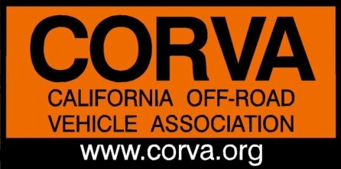
California Off-Road Vehicle Association Annual Board of Directors Meeting

Preliminary Meeting Agenda, Overview of OHV Recreation in California
April 26th, 2021 7:00pm to 9:00pm
Call in Phone Number: (712) 775-8968• Access Code: #104206

- 700 PM Call to Order

- 7:05 PM Welcome from President
      - Introduction/ Board of Directors and Guests
      - Review/Revise Agenda

- 7:10 PM Legislative/Lobbyist Review

- 7:20 PM OHMVR Commission review: Special Guest, Patricia Urena, Chair OHMVR Commission

- 7:40 PM OHMVR Division State Parks: Special Guest, Callen McLaughlin, Acting - Chief

- 8:00 PM Austin McInerney: Facilitator, Sac State Center for Collaborative Policy
Review of Forest Service in California

- 8:20 PM Carnegie SVRA: Diana M/Bruce B

- 8:30 PM Oceano Dunes

2021 ANNUAL MEETING
May 24th, 7pm
Call in Phone Number: (712) 775-8968• Access Code: #104206

- 7:00 PM Call to Order

      - Roll Call & Welcome from President
      - Introduction of Board of Directors and Guests
      - Review /Revise Agenda

- 7:15 PM Past President’s Trophy Announcement: Past Presidents

- 7:30 PM Officer Nominations and Elections: Ken Clarke and Amy Granat
      - President: Ken Clarke
      - VP Administration:
      - VP Sales and Marketing:
      - Secretary:

- 7:45/8:00 PM 2020 CORVA Awards
      - Nominations
      - Discussion
      - Voting by Board of Directors

- 9:00 PM Adjourn CORVA 2021 Annual Meeting

