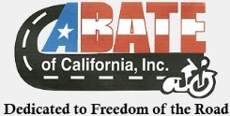 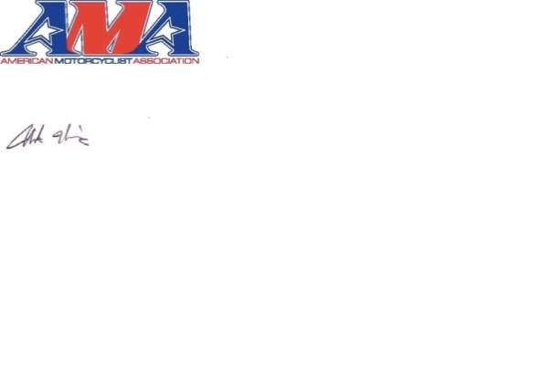 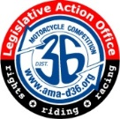 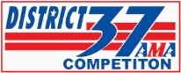 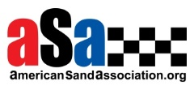

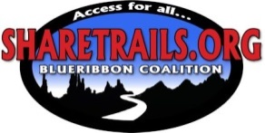 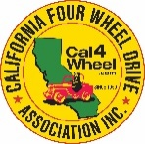  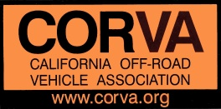 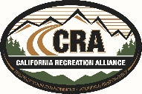

 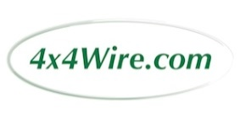   

 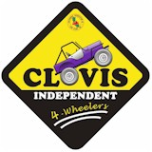 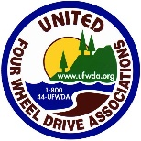

June 30, 2017

The Honorable Ben Allen

California State Senate Position: Oppose

State Capitol Building

Sacramento, CA 95814 Location: Senate Floor

**Re: SB 249 (Allen) Off-highway motor vehicle recreation (As Amended June 26, 2017)**

Dear Senator Allen,

On behalf of a coalition of off-highway recreation associations (Coalition) representing off-road recreation enthusiasts throughout the state of California, we regret that we must continue to oppose your Senate Bill 249 as it was amended on June 26, 2017. We also regret that not a single organized OHV group is able to support this bill – believing that the high price tag associated with the legislation inhibits safe, environmentally alert, legal and family oriented OHV recreation.

The legislation was drafted without our involvement and, while some concessions have been made as it wends its way through the process, the bill still re-focuses a highly successful recreation program at the nine of our two hundred and eighty parks set aside of motorized recreation, into an environmental wish list that appears to us to be one-sided. It is our belief that the program put in place by the Steinberg bill ten years ago may not be perfect, but the focus on recreation, environmental protections – including Best Management Practices designed and implemented by environmental scientists and cultural archeologists – law enforcement and education is working.

We are also concerned by the maneuvering that removed the financial aspects of the bill in an effort to mute the voice of policymakers. Senator Steinberg and others respected the idea that policy and cost should be considered together, and the result was a collaborative bill that resulted in near unanimity of support in the Legislature.

Since the creation of the California Off-Highway Vehicle program with the passage of the Chappie-Z’Berg OHV Act in 1971, Coalition members have played an important role as stakeholders each time the program has come up for sunset review and reauthorization. Coalition members have a wide variety of expertise in all issues relating to OHV recreation, both technical and environmental, with specific knowledge on the interaction between state and federal land management processes.

We recognize the amendments to the bill that have been made in response to our previously submitted comments. However, the disadvantage of working off a bill sponsored by those with little appreciation for OHV activity instead of beginning with statute as we have done in the past leaves us with entire sections that significantly alter priorities in ways that are obviously unacceptable to active California recreationists. Reading through the bill there are numerous examples of incorrect definitions, calls for unnecessary reports, and demands for duplicative agency consultation that portray a lack of understanding of the interplay required to create best management practices for areas that host off-road recreation.

It is clear that off-road knowledge and expertise were not used to craft the bill, but that the bill was conceived and written with a goal of unduly hampering and purposely setting roadblocks to a program that is world renowned for its existing high standards with regards to both recreation opportunities and environmental conditions. Furthermore there is no accountability for either reliably foreseen or unanticipated consequences of the drastic measures called for in the bill. The magnitude of the costs to the state for land restoration and mitigation for federal, city and county lands as called for by SB 249 because the corresponding agencies are eligible for grant funding through the OHV Trust Fund, would be in the millions of dollars if it would even be possible. This may be an unintended consequence of the bill, but is an example of the errors in fact and judgment that would cause extreme hardship to the state.

Some of the most concerning issues:

* Sections 3 and 4 contain errors in the description of adaptive management as it is used in conjunction with a monitoring program. To those experienced in land policy, adaptive management is an ongoing process of evaluation leading to changes in operations to improve on-the-ground conditions. Many components are part of this process, although the bill stresses solely natural and cultural resources. We would add that water quality, erosion and sedimentation evaluations are equally critical, although none of these important issues are mentioned. Furthermore, natural and cultural resources are mentioned many times in the bill without adequate definition which would only lead to confusion in the future.
* Section 9 contains some of the more disconcerting changes proposed in the bill. Subsection (g) seeks to remove access to existing roads in state vehicular recreation areas by the public that were created earlier by previous land owners. This subsection would seek to benefit adjacent landowners with easements through state property while creating a management burden for the state. More troubling is subsection (m) that would require the state to compile reports of accidents, citations and other infractions from all areas of the state, including federal land, where off-road recreation occurs. This is a burden placed on no other unit of state parks, the information is not currently collected by state parks, nor is it required by any federal agency. Furthermore there is no justification for the need for this report, leading the Coalition to conclude the need lies in a wish to discredit off-road recreation.
* Section 11 requires the Off-Highway Motorized Vehicle Recreation Division to change its purpose from anything to do with offering off-road recreation, instead stating the most important mission is the protection of natural and cultural resources. Leaving aside the lack of definition for ‘natural and cultural resources,’ this is an inappropriate change for a division that manages state vehicular recreation areas. This is not even a definition that has been adopted by parks, because the department recognizes the need to combine recreation activities with environmental protections. Some areas are set aside by the state as reserves that have extraordinary natural conditions, but state vehicular recreation areas are largely located on highly disturbed land that was acquired by the state for the specific reason of offering motorized recreation. The need to redefine the purpose of the division is not explained because the premise is contradictory by its very language.

Section 11 also has proposed the elimination of the words; ‘to the extent possible’ when talking of restoration work taking place in state vehicular recreation areas. The bill seeks to portray and require restoration work to be done in an absolute fashion, and be fully mitigated no matter the cause of the damage. Rain and other weather phenomena can cause considerable damage yet the effect of this damage is not differentiated from ongoing maintenance due to OHV activities. Other state parks are not responsible for acts of Mother Nature and it is inappropriate to place that burden on this program and this division. Minimizing impact to land from all forms of human interaction, whether through motorized or non-motorized activities is a goal already undertaken by all park units to the extent possible, therefore we request the restoration of those words to this section.

To be clear, adding numerous agencies for consultation and written reports as requirements to be produced, does nothing to improve environmental conditions on the ground. The redirected time will make performing environmental activities and restoration difficult, be extremely time consuming and add a considerable cost consideration for all entities concerned, when there is no indication that anything is amiss in the current program. These new requirements would cause a diminishment in environmental conditions, which those with experience in off-road recreation management recognize with great concern.

* Section 12 seeks to expand the concept of ‘wildlife corridors’ beyond the limited and voluntary scope defined in PRC section 1305.5 (c) (1), which was discussed in this Committee as recently as the last session of the legislature. Accepting this language will expose the OHV program to additional litigation and could open up ramifications to all state parks should this concept be expanded as proposed here.

Senator Allen, we respectfully regret that the coalition must request the members of the Assembly Water, Parks and Wildlife Committee take an oppose position on SB 249.

The OHMVR Division does much more than manage State Vehicular Recreation Areas; everything from law enforcement to the economic viability of rural counties and the interests of federal and local partners is integrated within the management of this division. Unfortunately, in talking with Parks the new environmental costs exceed eleven million dollars, and the environmental precedents being set are above even what is expected in non-ohmvr parks.

Sincerely,

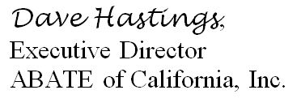

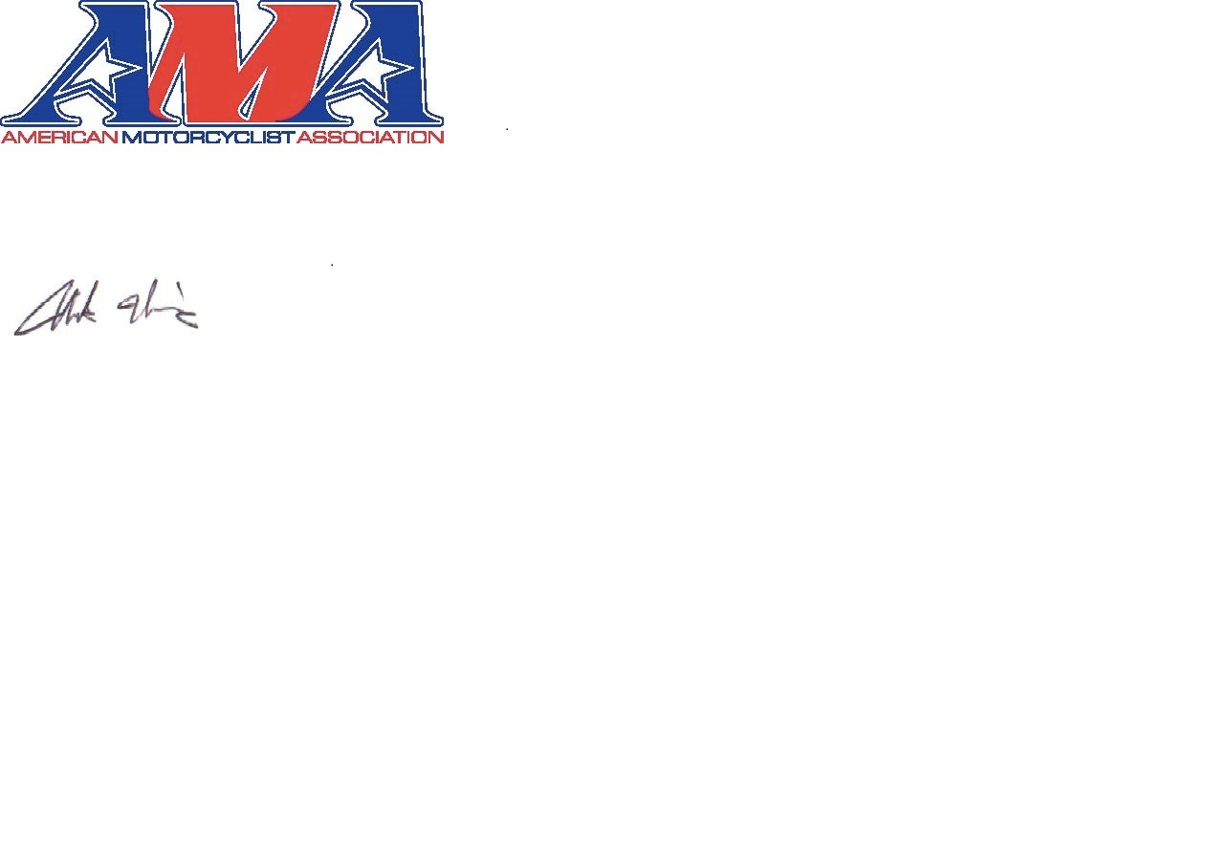

Nicholas Haris, Western States Representative

American Motorcyclist Association



Dave Pickett, Legislative Action Office Director

D36 American Motorcyclist Association

Member of the Board of Directors

American Motorcyclist Assoc. Congressman

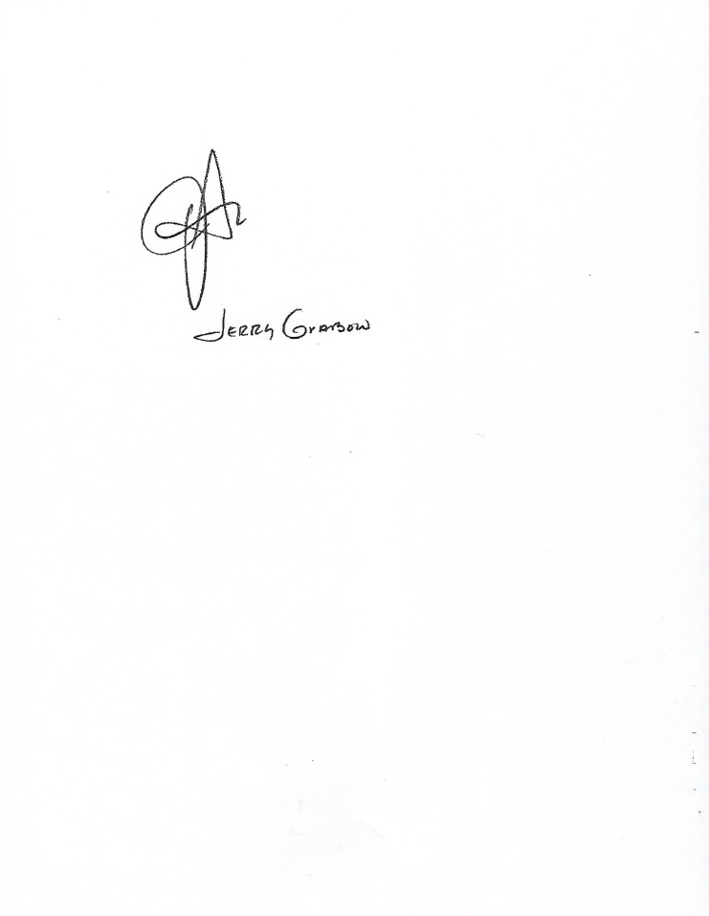

Jerry Grabow, President

D37 American Motorcyclist Association

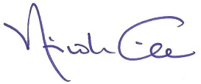

Nicole Nicholas Gilles, Executive Director

American Sand Association

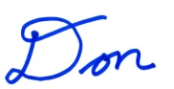

Don Amador, Western Representative

Blue Ribbon Coalition / Sharetrails.org

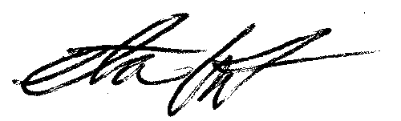

Steve Egbert, President

California Four Wheel Drive Association, Inc.

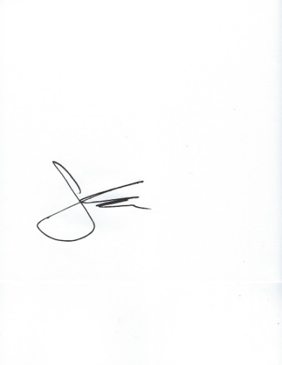

John Paliwoda, Executive Director

California Motorcycle Dealers Association

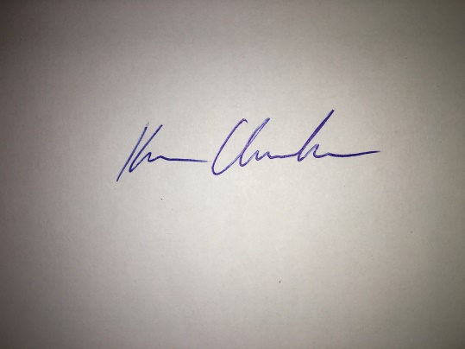

Ken Clarke, President

California Off-Road Vehicle Association

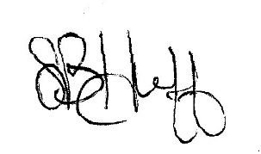

Sarah Huff, Program Director

California Recreation Alliance



Jerry Grabow, Chairman

Ecologic Partners

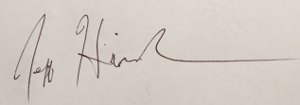

Jeff Hindman, President

Clovis Independent Four Wheelers

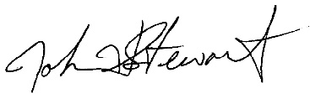

John Stewart, Publisher/Editor

4x4Wire.com

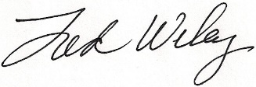

Fred Wiley, President/CEO

Off Road Business Association

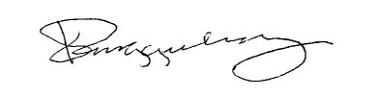

Keith Ringgenberg

President, Outdoor Sportsmen's Coalition

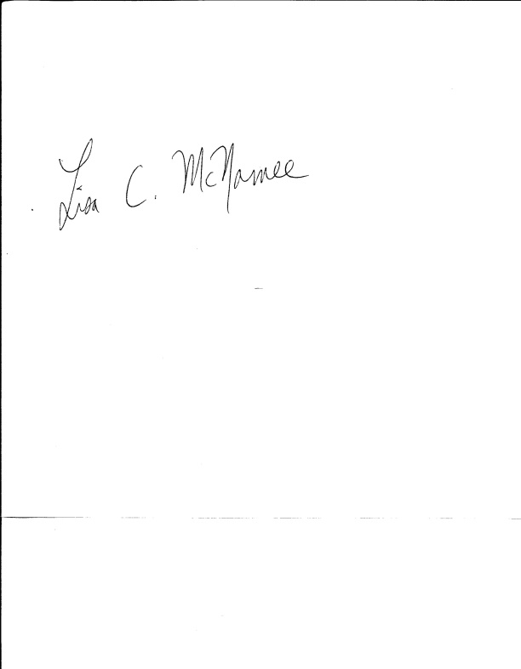

Lisa C. McNamee, Co-Legislative Coordinator

SCI CA Coalition

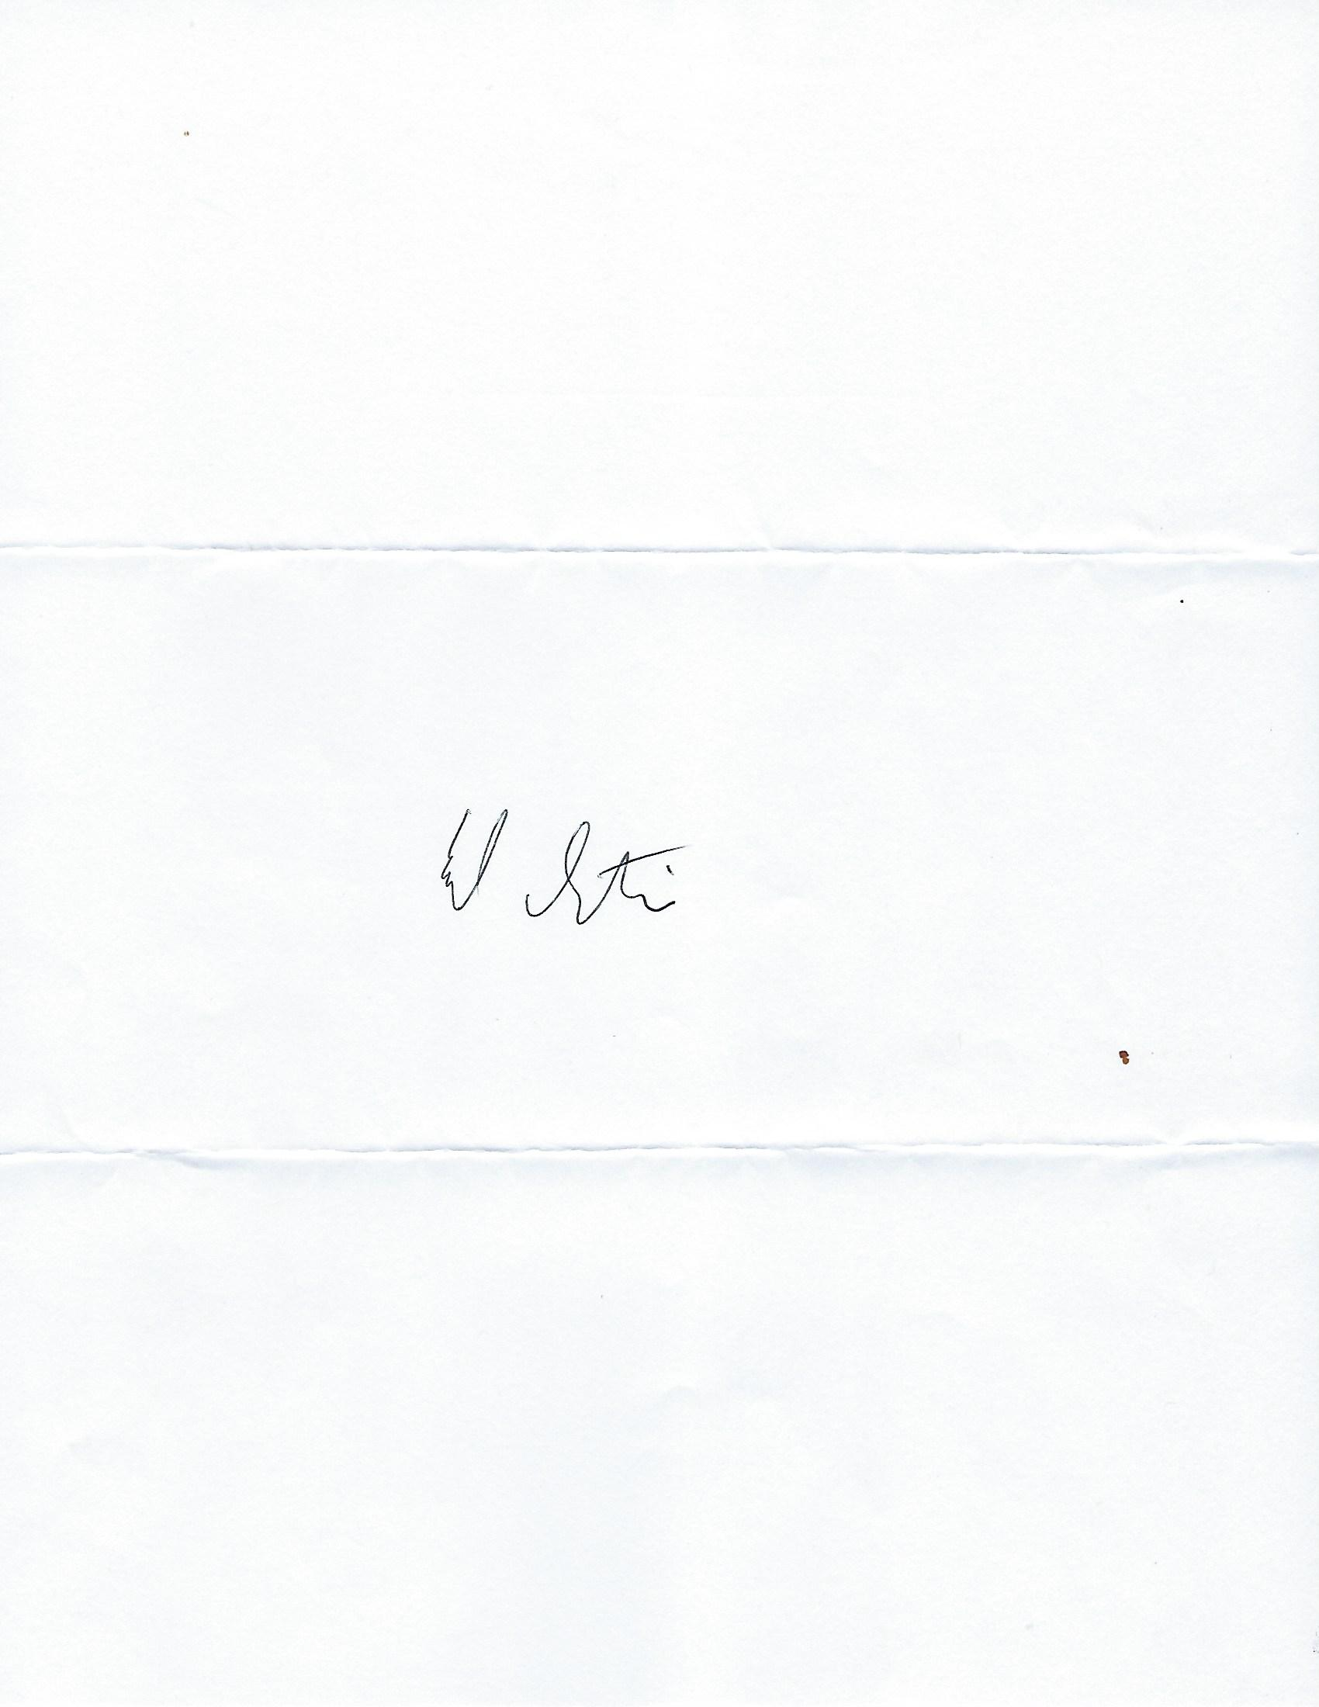

Ed Stovin, President

San Diego Off-Road Coalition



Steve Egbert, Vice President

United Four Wheel Drive Association, Inc.

cc: Mr. Daniel Seeman, Deputy Legislative Secretary, Governor’s Office

Ms. Catherine Freeman, Consultant, Assembly Water, Parks and Wildlife Committee

Mr. Robert Spiegel, Consultant, Assembly Republican Caucus

Assembly Water, Parks and Wildlife Committee